

**RESUME**



**ANITHA**

**.T**

Cell :

8807043615

ADDRESS:

53

/C south

Street

Maligaithidal,

Valangaiman(Tk),

Thiruvarur(Dt)

,

614302

Email id

:

anitha232004@gmail.com

CAREER OBJECTIVES:

*To achieve excellence by applying my knowledge &skills in profession and*

*continuously improving my knowledge base by learning through work*

*experience and to make*

*significant contribution*

*in the growth of*

*organization.*

EDUATION:

y

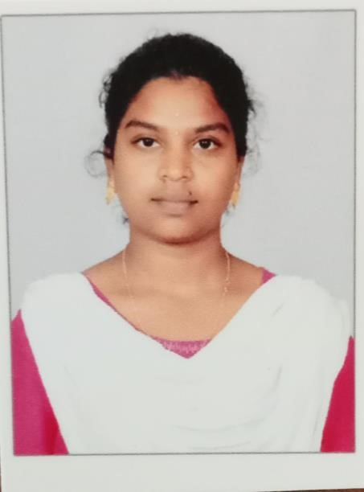

|  |
| --- |
| *CLASS X:*  *GHSS: Thirukkarukavur*  *Medium: Tamil*  *Year of passing:2019 Grade:333*  *CLASS XII:*  *GHSS: Thirukarukavur*  *Medium: Tamil*  *Year of passing:2021 Grade:439*  *COLLEGE:*  *III-B.sc (Computer science) final year student*  *Thiru.Vi.Ka.Govt arts &S*cience, *college thiruvarur*  *Bharadhidasan university*    AMBHITION:     * *I Try to well salary for government job* * *I Will be create App developer*     HOBBIES:  *Listening music, Watching thriller movie, Drawing , Play settle cork, tailoring, cooking, reading books.*        DECLARATION:  *I hereby declare that all above mentioned information is true to the best of my knowledge and belief.*    YOUR’S FAITHFULLY:-  T.ANITHA |